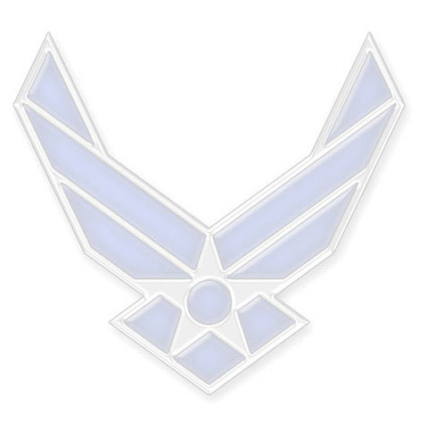
MASTER SERGEANT JOHN A. DOE
(12pt Arial bold, left above text, double space between name heading and Narrative)

(10pt Arial -- Position title, organization, base, location. Give a brief description of position responsibilities) Sergeant Doe advises and assists the commander, vice commander, and command chief on matters concerning the discipline, health, morale, welfare, and mentorship of more than 1,500 military and civilian personnel and their families. He also counsels 19 directorates and special staff members on personal affairs, adjudicates complaints and coordinates with various base agencies.

(Second and third (if necessary) paragraphs usually include prior career fields and/or prior service (if applicable), overview of positions held, and other noteworthy assignments or events.)

EDUCATION (Double space between heading and first entry. List both civilian degrees and professional military education (major, college, location), with no periods after bullets.)

1993 Airmen Leadership School, Peterson AFB, CO
1994 Associate’s Degree in Criminal Justice, Community College of the Air Force
2000 Paralegal Apprentice Course, Maxwell AFB, AL
2001 Noncommissioned Officer Academy, Tyndall AFB, FL
2003 Paralegal Craftsman Course, Maxwell AFB, AL
2003 Associate’s Degree in Paralegal Studies, Community College of the Air Force
2003 Senior Noncommissioned Officer Academy Correspondence Course
2004 USAF First Sergeant Academy, Gunter Annex-Maxwell AFB, AL
2005 Associate’s Degree in Human Resource Management, Community College of the Air Force
2006 Senior Noncommissioned Officer Academy, Gunter Annex-Maxwell AFB, AL
2010 Senior Noncommissioned Officer Joint PME Correspondence Course
2013 Bachelor of Arts Degree in Human Resource Management, American Military University

ASSIGNMENTS (Double space between heading and first entry. List assignments in chronological order, starting with the earliest assignment. Put deployments in parentheses. No periods after bullets.)

1. May 1990-Jul 1990, Trainee, 3708th Basic Military Training Squadron, Lackland AFB, Texas
2. Jul 1990-Aug 1990, Student, 3461st Student Training Squadron, Lowry AFB, Colorado
3. Aug 1990-Jul 1993, 7th Supply Squadron, Carswell AFB, Texas
4. Jul 1993-Dec 1995, 609th Air Support Operations Squadron, Shaw AFB, South Carolina
5. Dec 1995-Jul 1999, PME Instructor, 20th Mission Support Squadron, Shaw AFB, South Carolina
6. Jul 1999-Jun 2003, Air Force Pentagon Communications Agency, Pentagon, Washington, DC
7. Jun 2003-Sep 2004, 39th Communications Squadron, Incirlik AB, Turkey
8. Sep 2004-Oct 2006, AF Institute for Advanced Distributed Learning, Maxwell AFB, Alabama
9. Nov 2006-Mar 2009, First Sergeant, 42d Medical Group, Maxwell AFB, Alabama
(Deployed Jan-May 2008, First Sergeant, 455th Expeditionary Mission Support Group)
10. Mar 2009-Mar 2011, First Sergeant, 436th Aerial Port Squadron, Dover AFB, Delaware
(Deployed Dec 2009-Apr 2010, First Sergeant, 379th Expeditionary Aircraft Maintenance Squadron)

MAJOR AWARDS AND DECORATIONS (Double space between heading and first entry. List in descending order of precedence. May limit to most significant awards and decorations)

Air Force Meritorious Service Medal with three oak leaf clusters
Air Force Commendation Medal with three oak leaf clusters
Air Force Achievement Medal with oak leaf cluster

OTHER ACHIEVEMENTS (Double space between heading and first entry. List in descending order of precedence. May limit to most significant awards and decorations)

1993 Military Citizen Award, Airmen Leadership School
2000 Julie Y. Cross/Women in Law Enforcement of the Year, AETC
2001 Distinguished Graduate, Tyndall Noncommissioned Officer Academy
2001 SNCO of the Year, 88th Air Base Wing Staff Agency
2004 Top Graduate, USAF First Sergeant Academy
2005 First Sergeant of the Year, Air Force Flight Test Center/Edwards AFB
2006 Distinguished Graduate, Senior Noncommissioned Officer Academy
2007 First Sergeant of the Year, Air Force Flight Test Center/Edwards AFB
2009 Senior Paralegal of the Year, Fifth Air Force

EFFECTIVE DATES OF PROMOTION (Double space between heading and first entry. List in chronological order, starting with the earliest promotion)

Staff Sergeant 1 June 19XX
Technical Sergeant 1 December 19XX
Master Sergeant 1 June 19XX
Senior Master Sergeant 1 October 20XX

(Current as of January XXXX)

