Member User Guide
Military Member AF Form 938
All members can now do the initial create of their own orders.
If you need help creating an order contact your local Order Specialist or your Wing Administrator.
The orders will route to an Order Specialist to complete the orders for further routing.
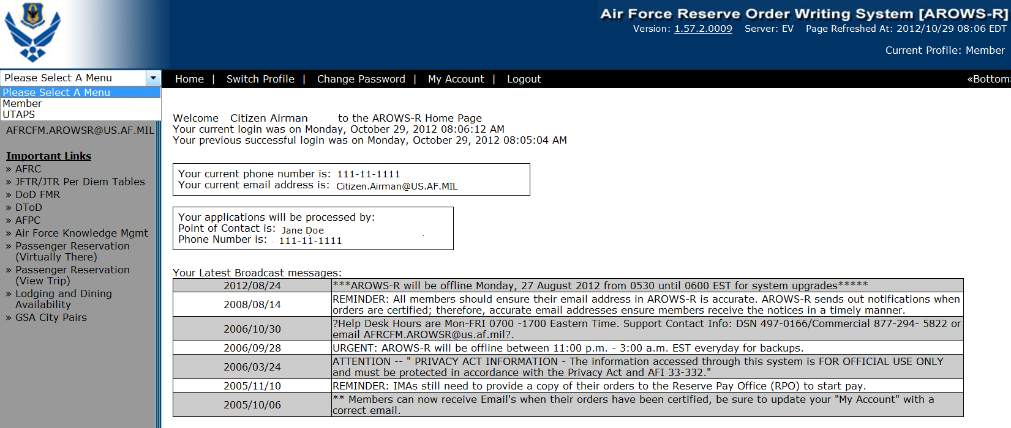
Select Member Profile. If you have multiple roles you must be in the your web profile role to create your own order.

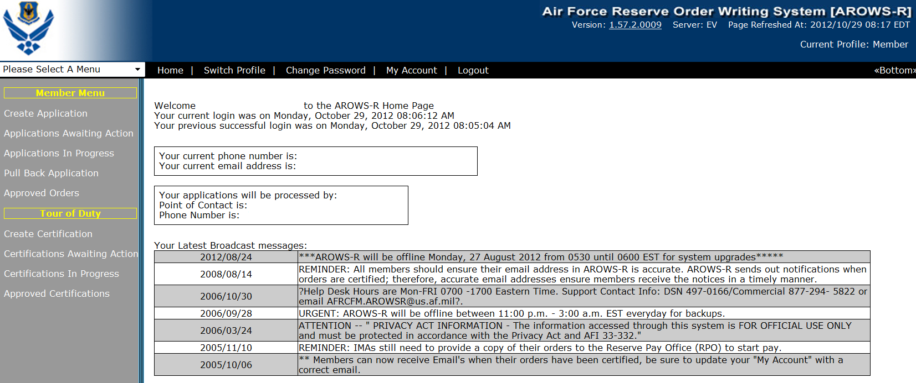
Create Application

Select Order Type and Create Application
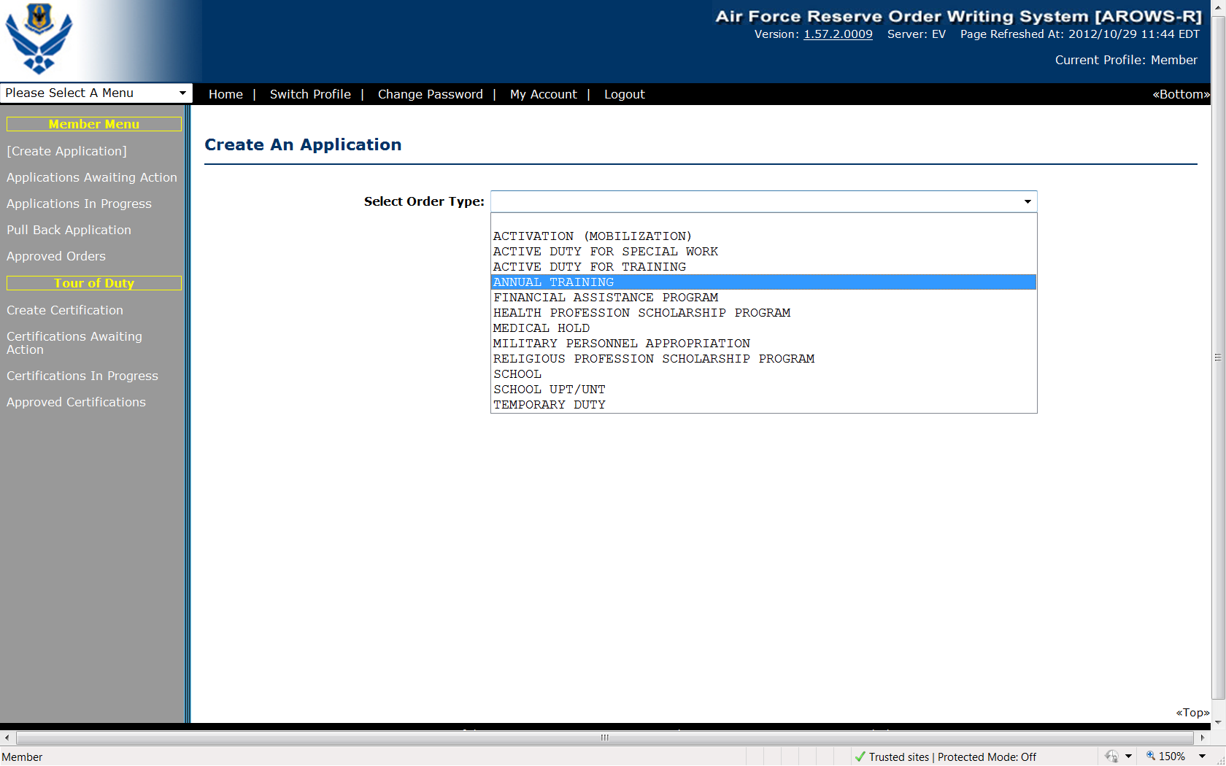

Overview
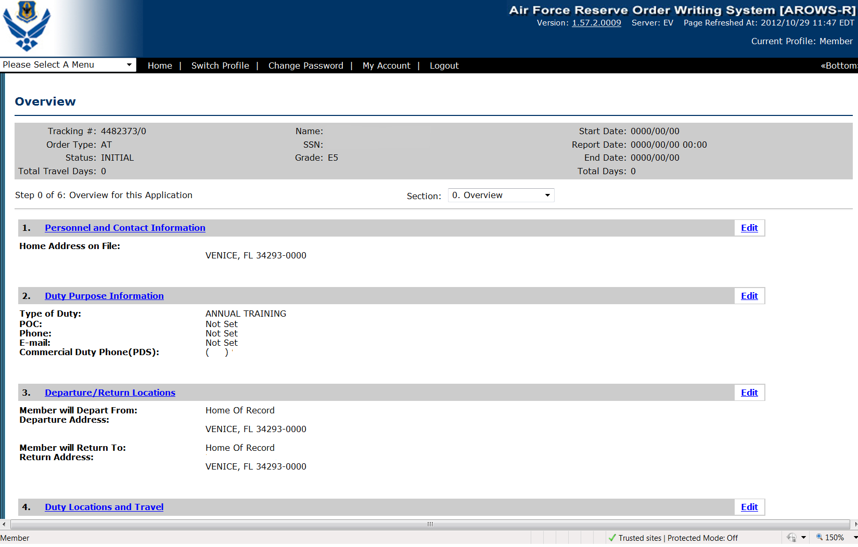
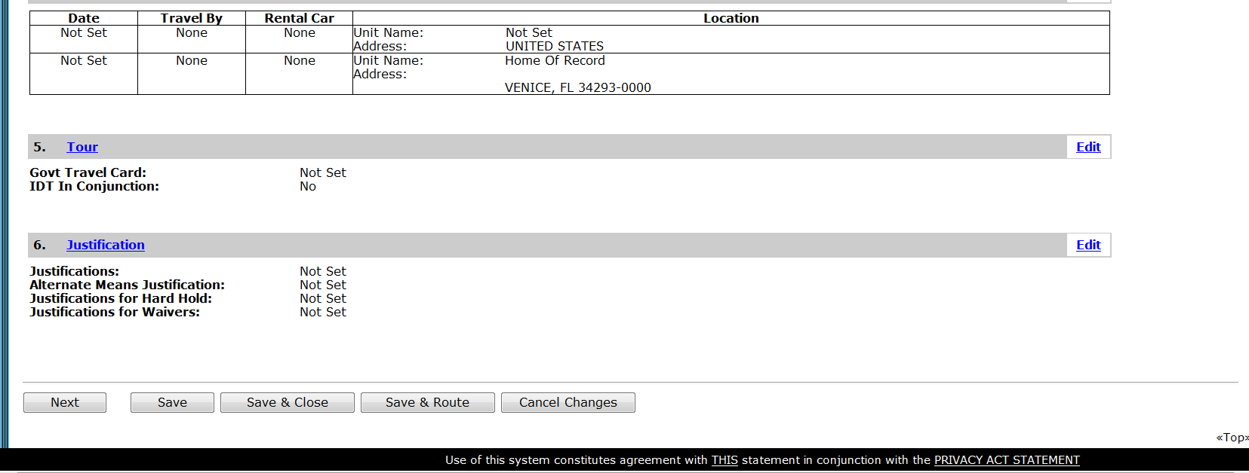
Select “Next”

Step 1 Personnel Info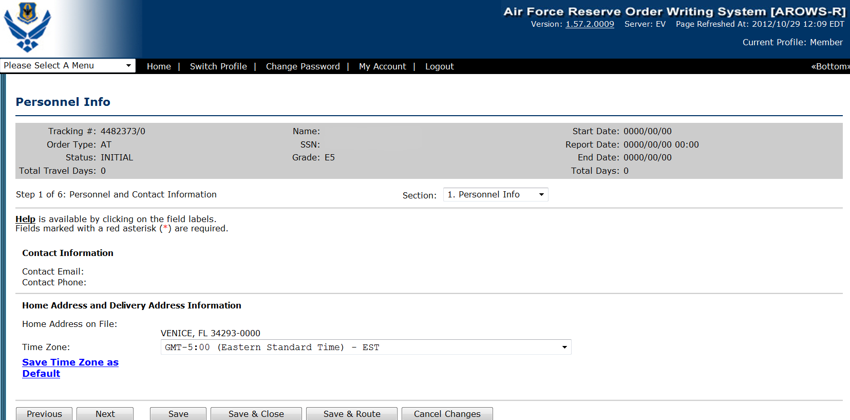
Home address is changed through MILPDS or Virtual MPF. Default Time Zone should be saved. Select Next.
Step 2 Duty Purpose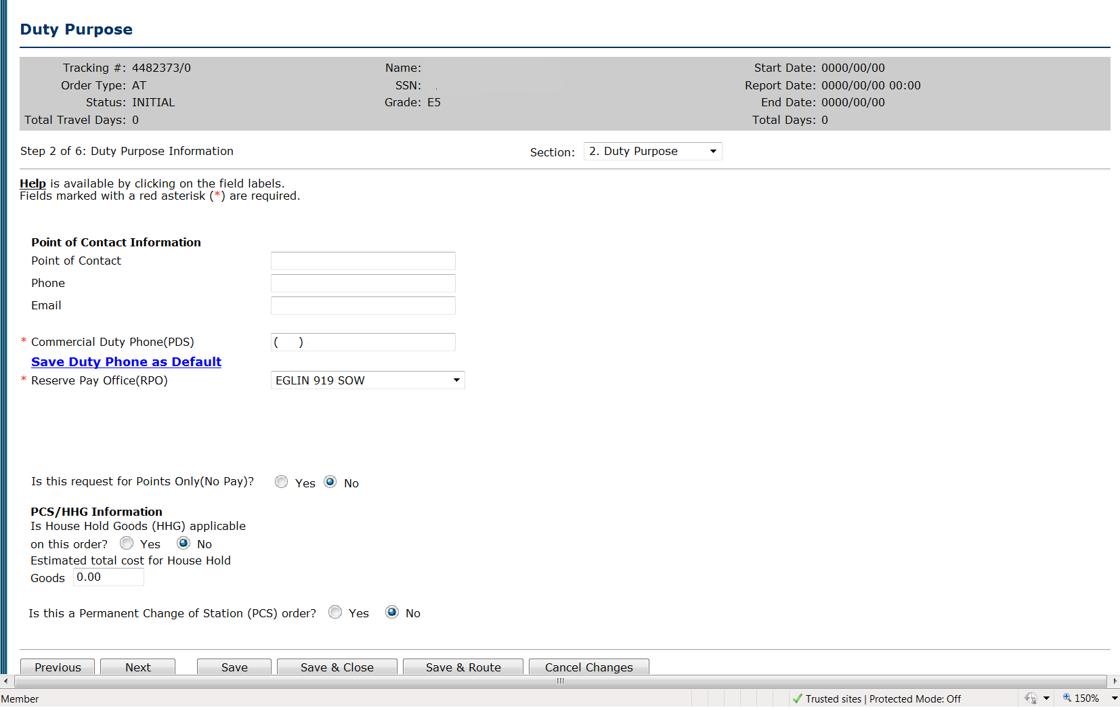
All red asterisk fields are required.
POC Information is optional.
Commercial duty phone is required.
Answer Points, PCS and HHG’s questions; Select Next
Step 3 Departure/Return Locations
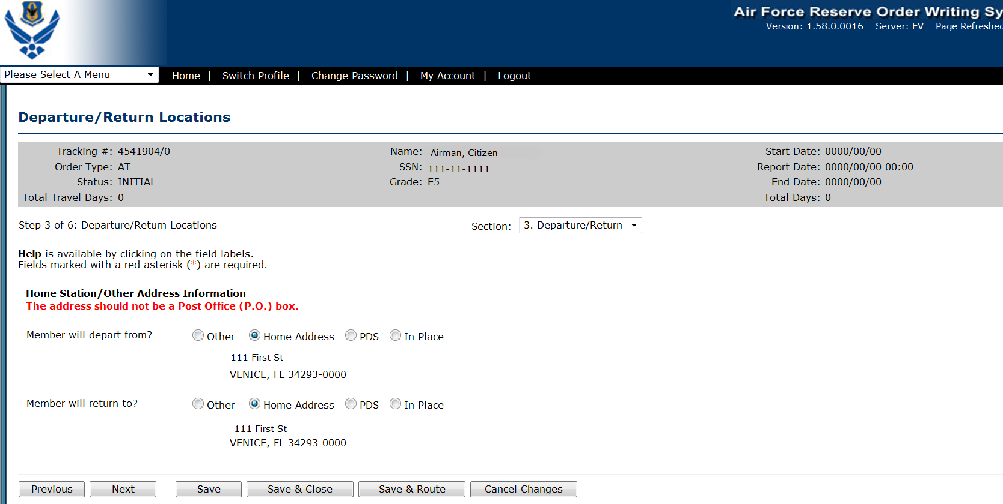
Select Departure and Return Locations.
Do not select “In Place” if member will be returning home between orders.
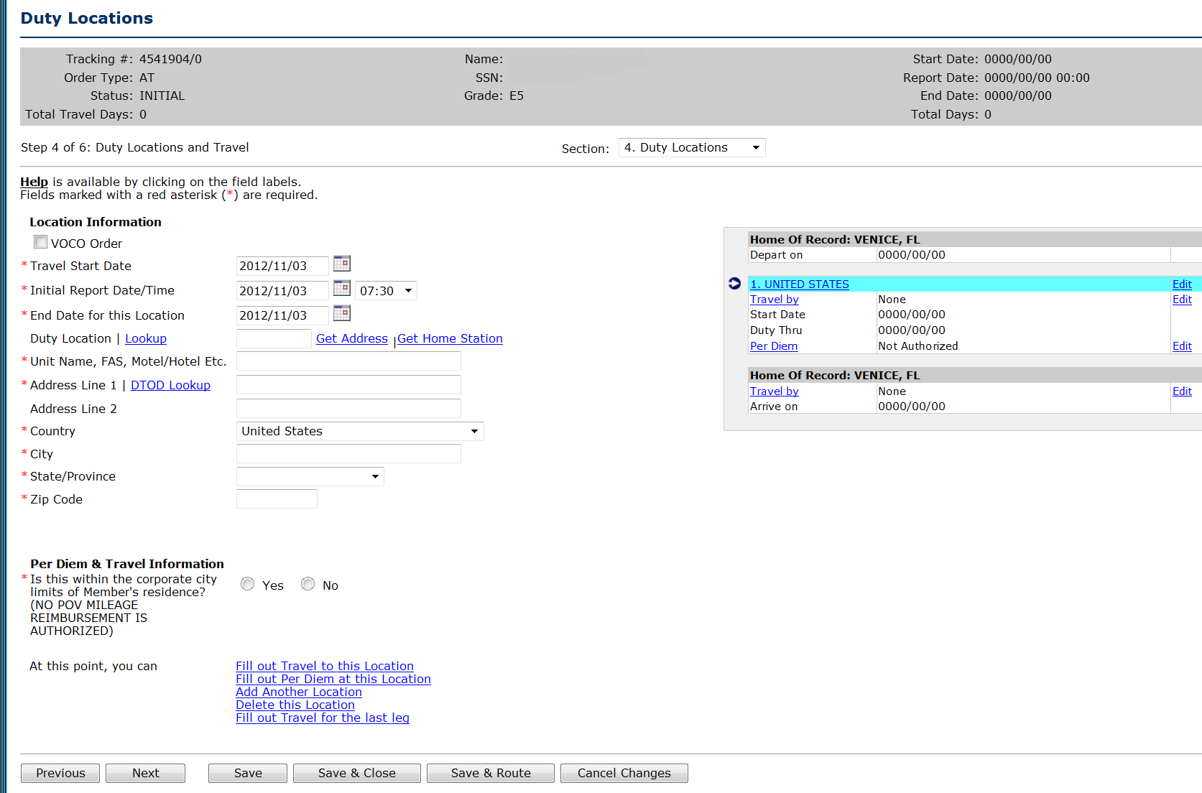
The difference between the travel start day and initial report day is the travel day on the front of the order. The difference in the end date of the duty location and the release date is the travel day on the end of the order.

Options for selecting duty locations:
- Duty location lookup
- Get Address hyperlink
- Get Home station hyperlink
- Type in Duty Location
Red Asterisk fields are required.
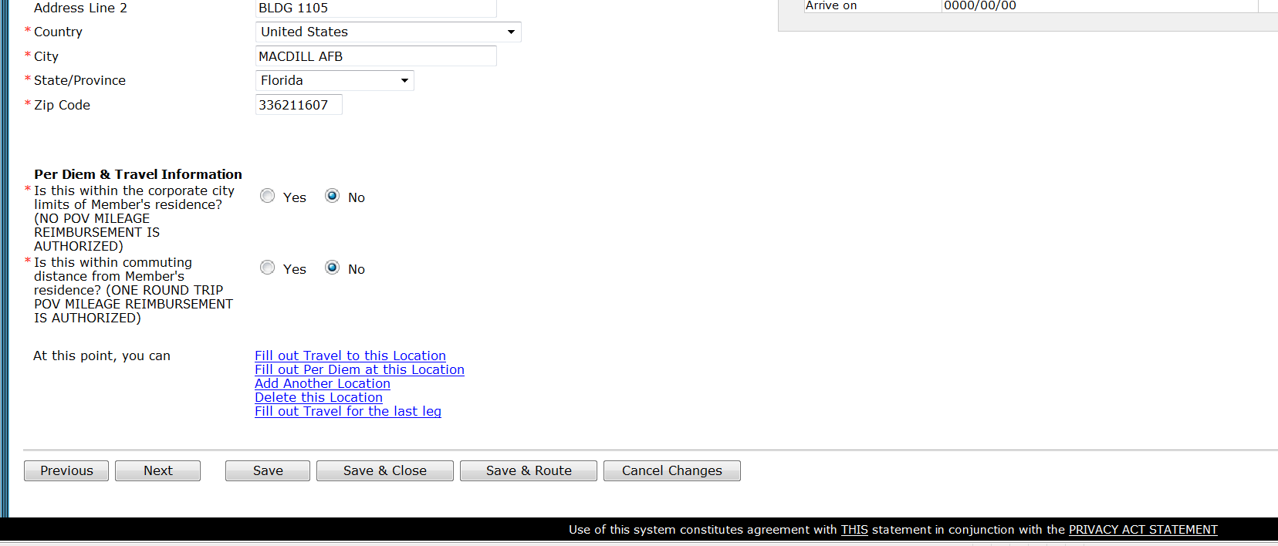
Answer Per Diem & Travel Information Questions; Select Next.
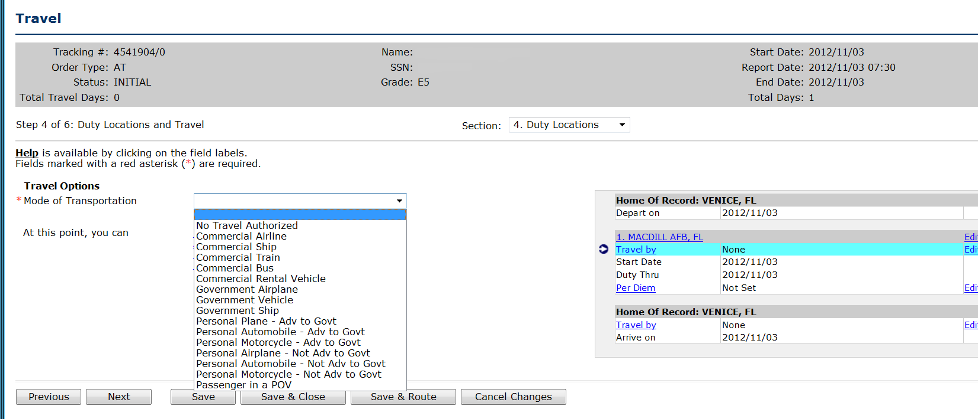
Select Mode of Transportation
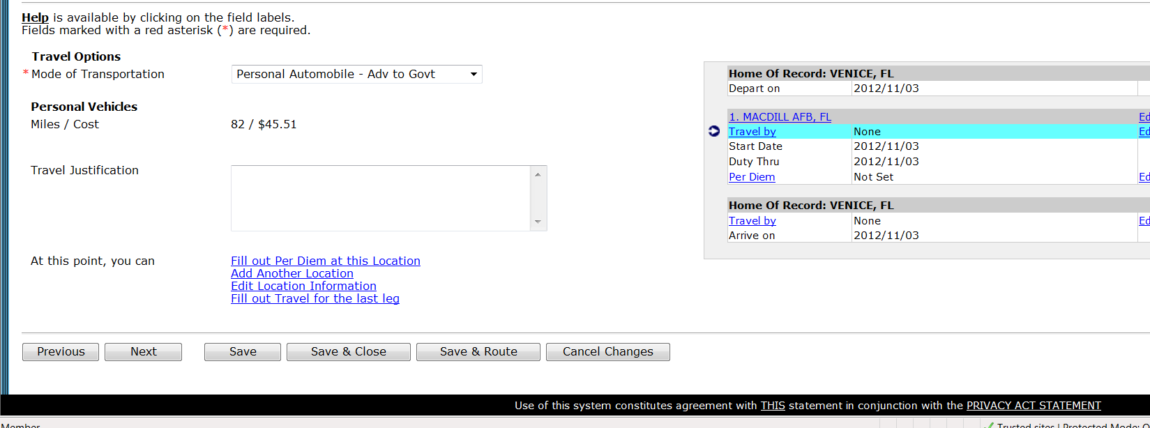
Select “Next”
Per Diem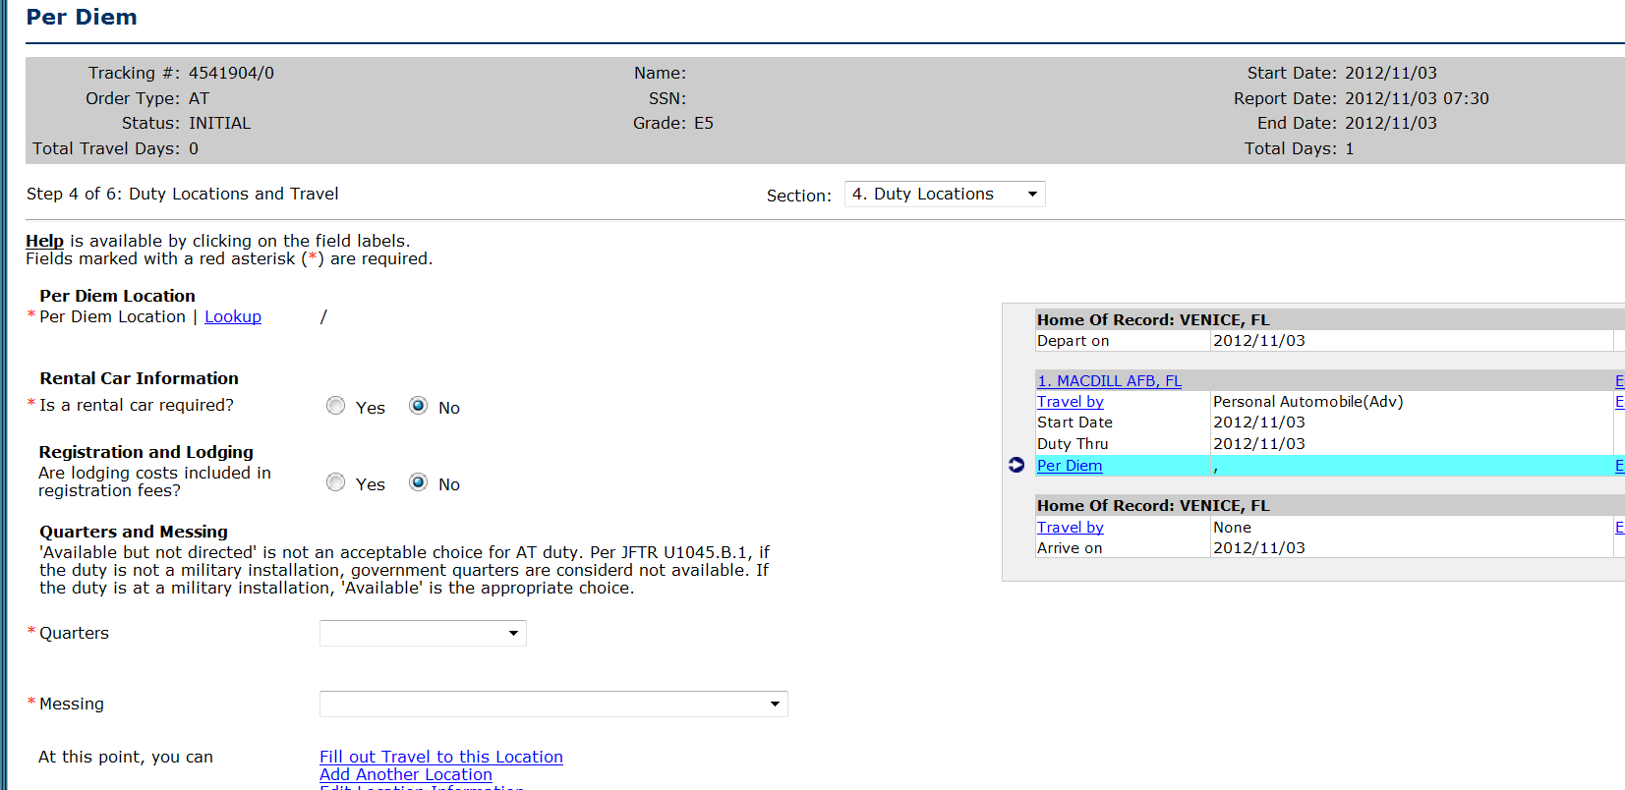
Select Per Diem hyperlink
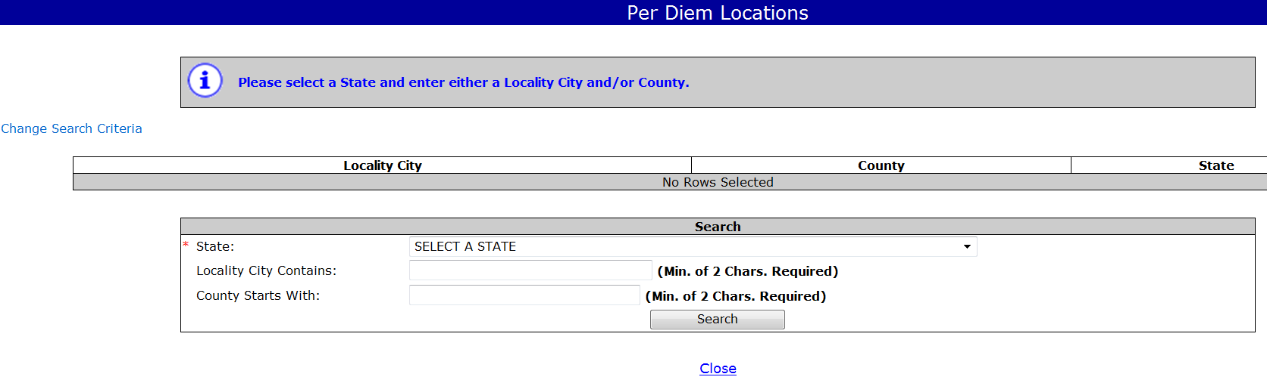
Select a state and city; Search
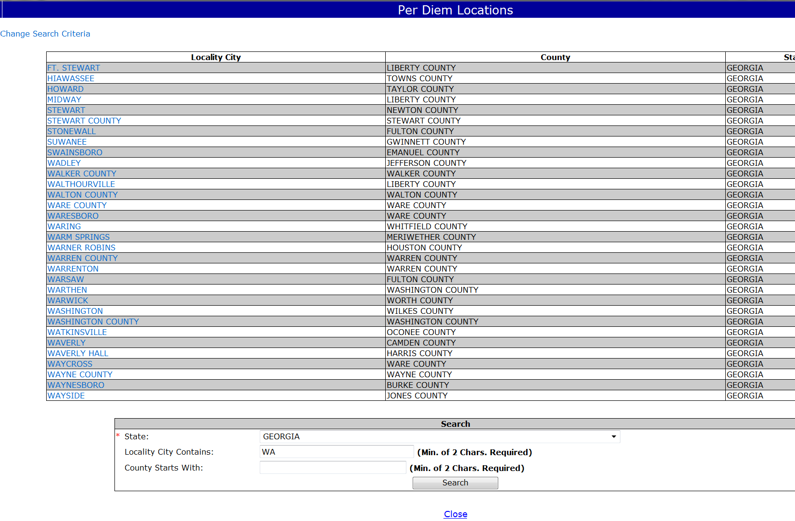
Select Per Diem Location
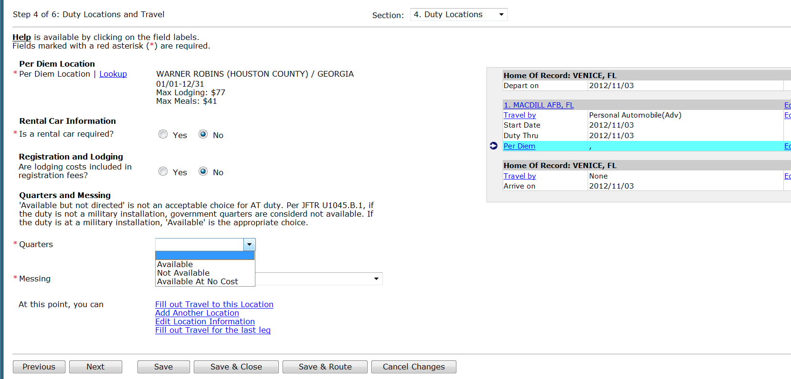
Answer Rental Car question. Any car other than Compact requires a Justification.
Answer Registration and Lodging question
Select Quarters and Messing availability
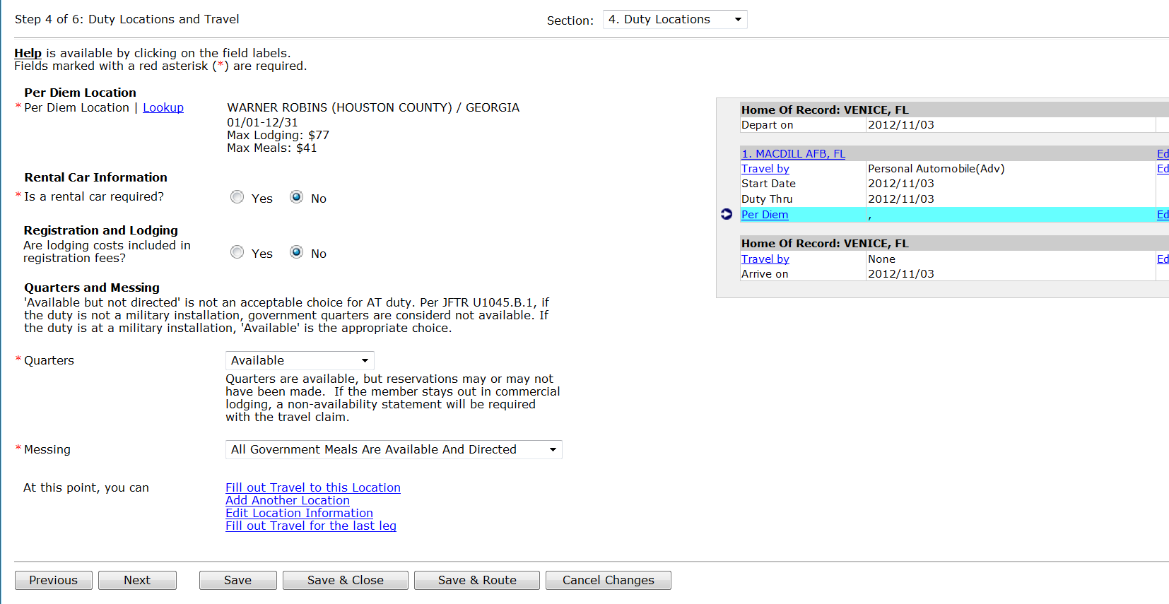
Select Next

Additional Duty Locations
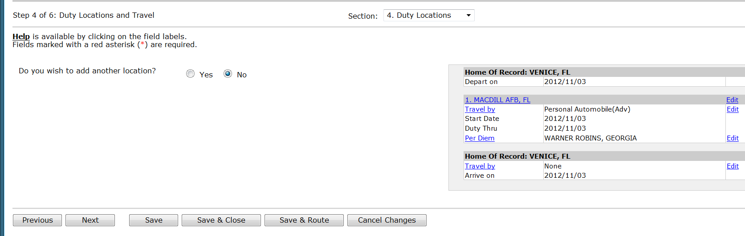
Answer “Yes” if there are other duty locations and “No” if not. Select “Next”

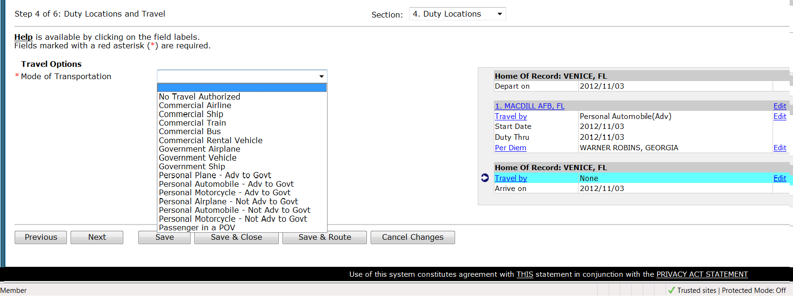
Select transportation for the leg home. “Next”

TOUR
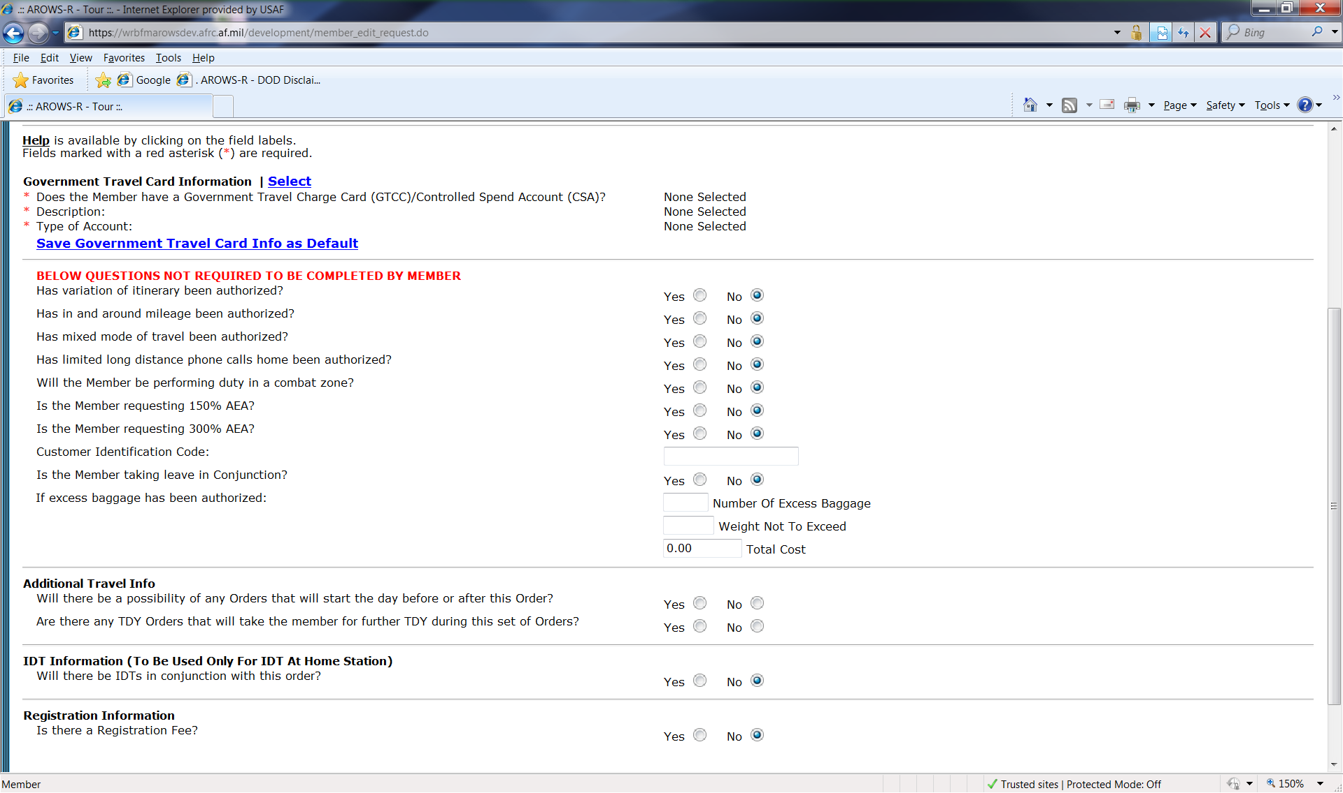
Select GTCC Info and save as Default
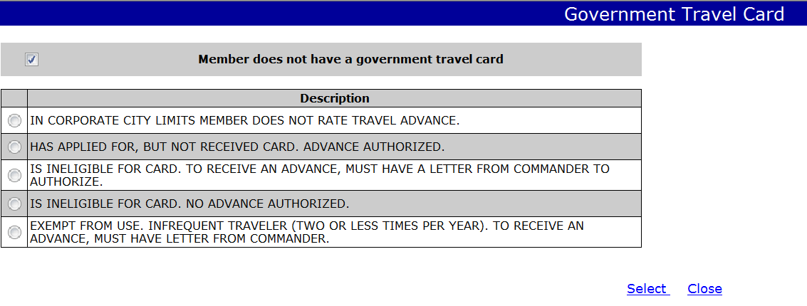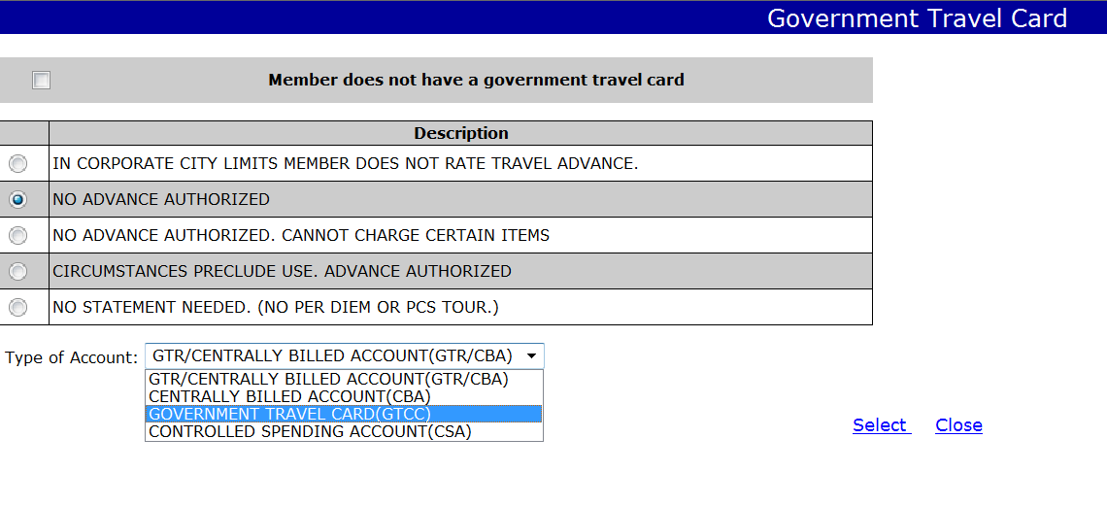
Tour
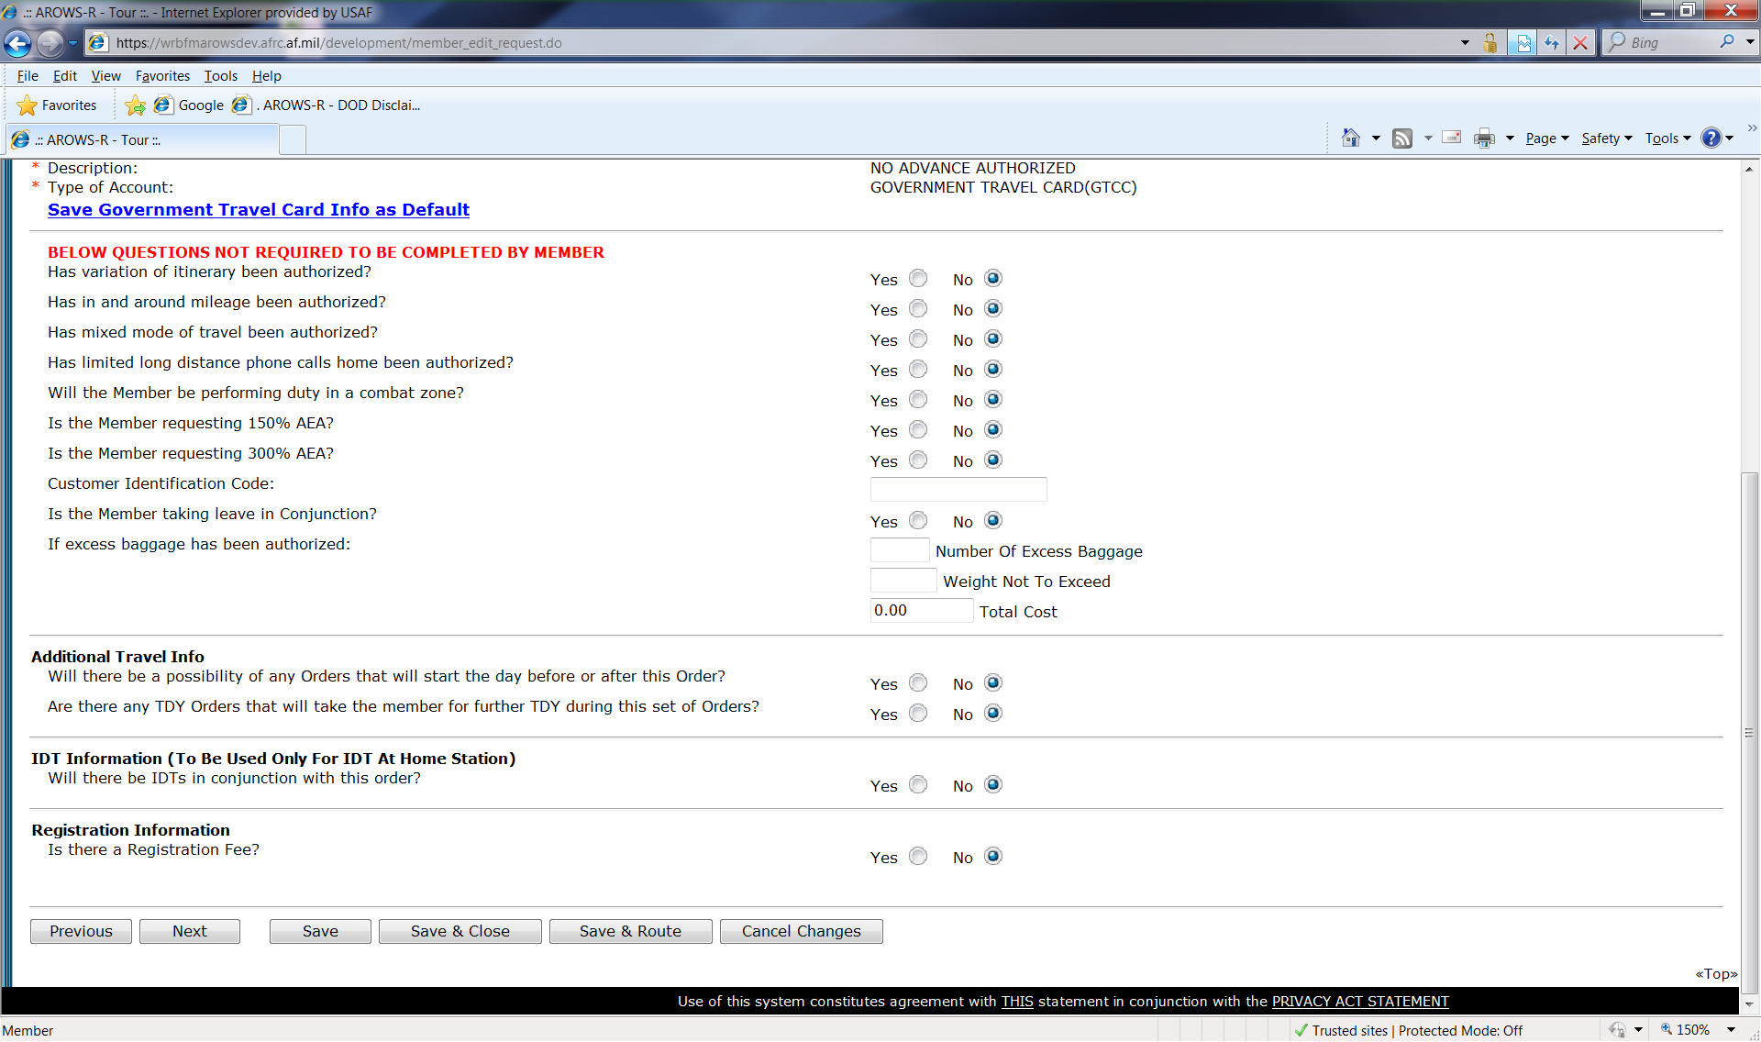
Answer all of the tour questions
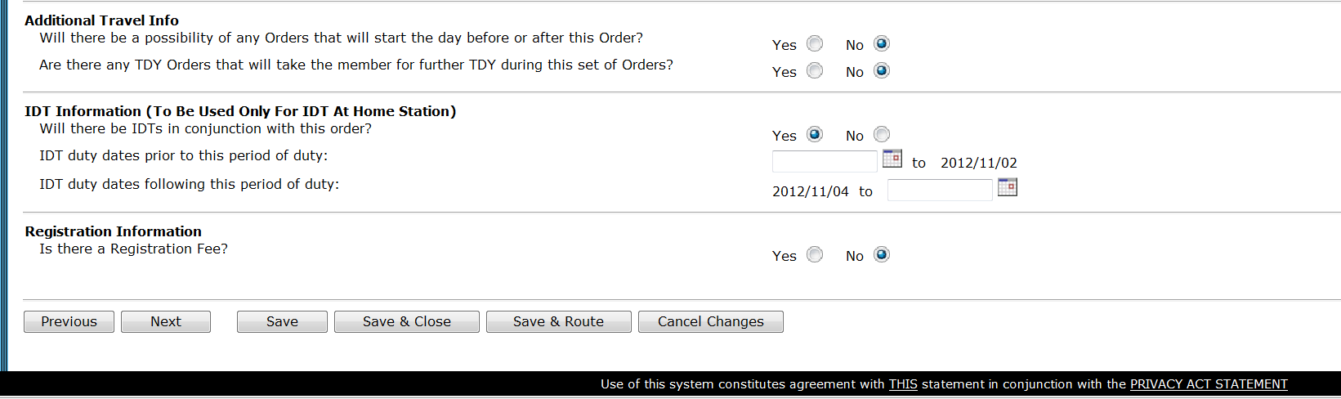
Input IDT dates if this order is IDT at Home Station in conjunction with this order.
Select Next

Justification
Orders back to back if member goes home between orders. 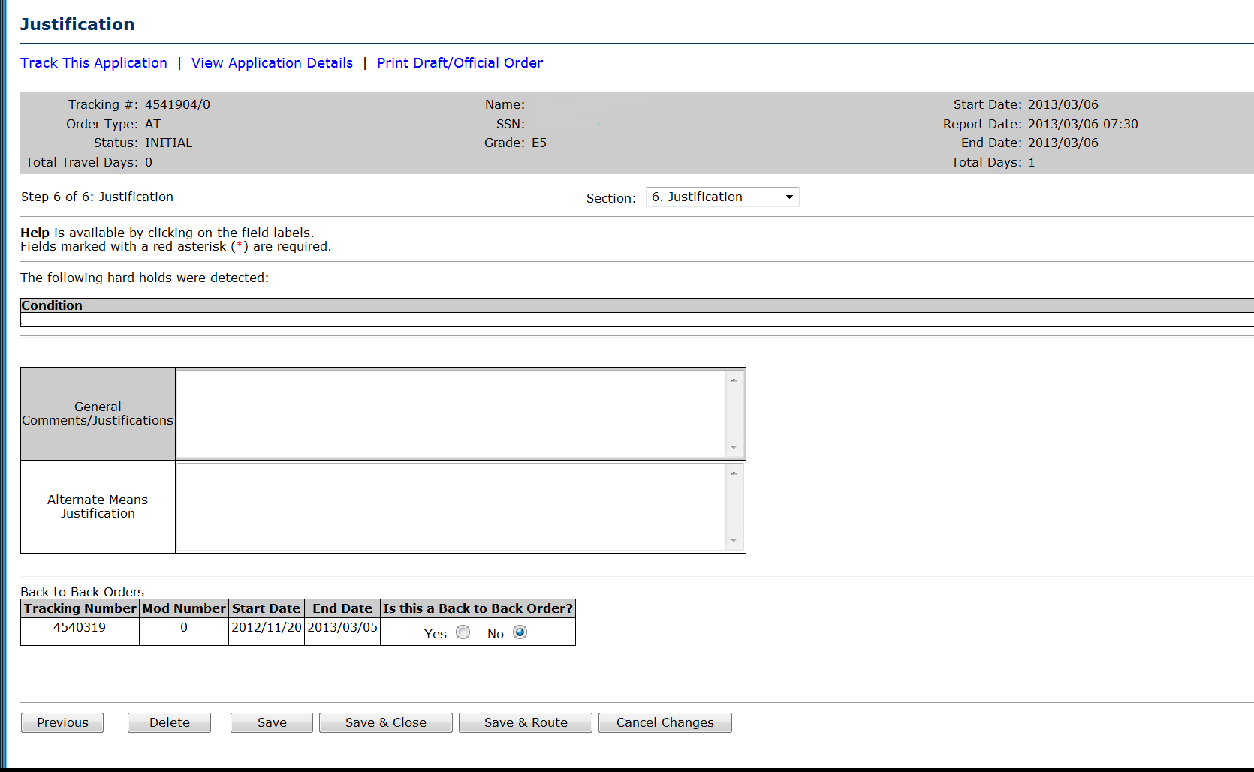
General Comments may be input for the Order Specialist.
Alternate means paragraph is required but may be input by the Order Specialist.
Do not mark orders back to back if member goes home between consecutive orde
Save & Route to your Order Specialist.

Military Member TDY
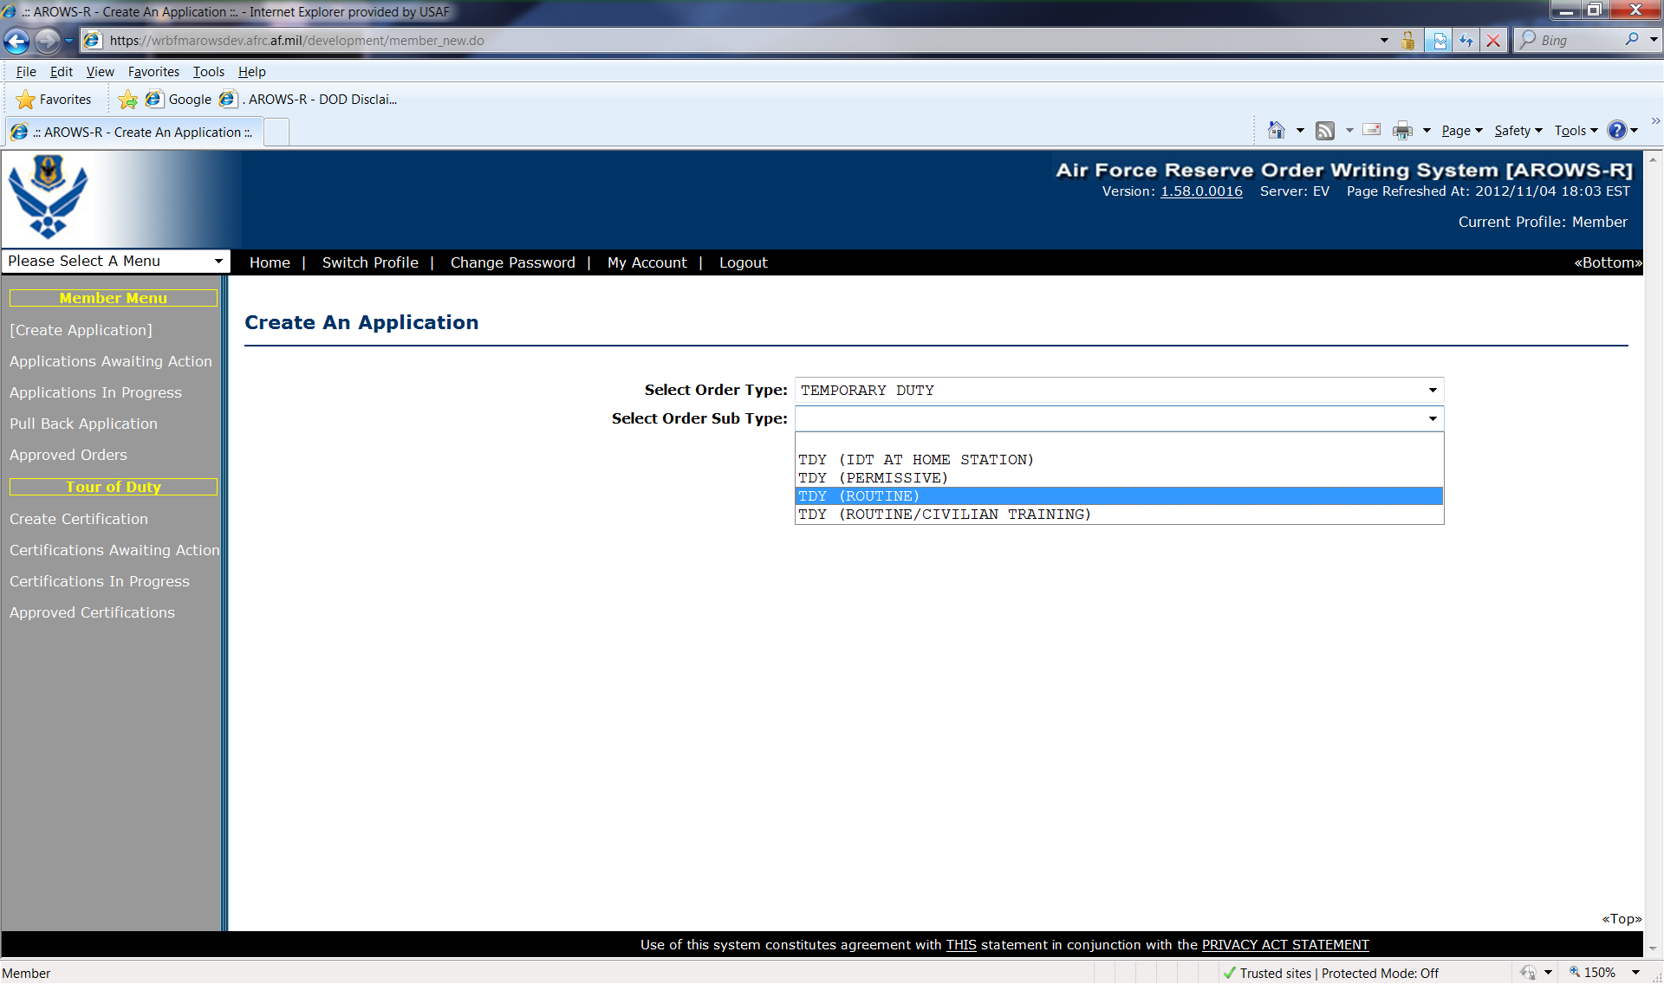
Select Temporary Duty
Select TDY (Routine)
Create Application
Military Member must first be called to Active Duty on a 938 before creating a 1610 except for IDT Outside Normal Commute and IDT Away from Home Station.

Overview
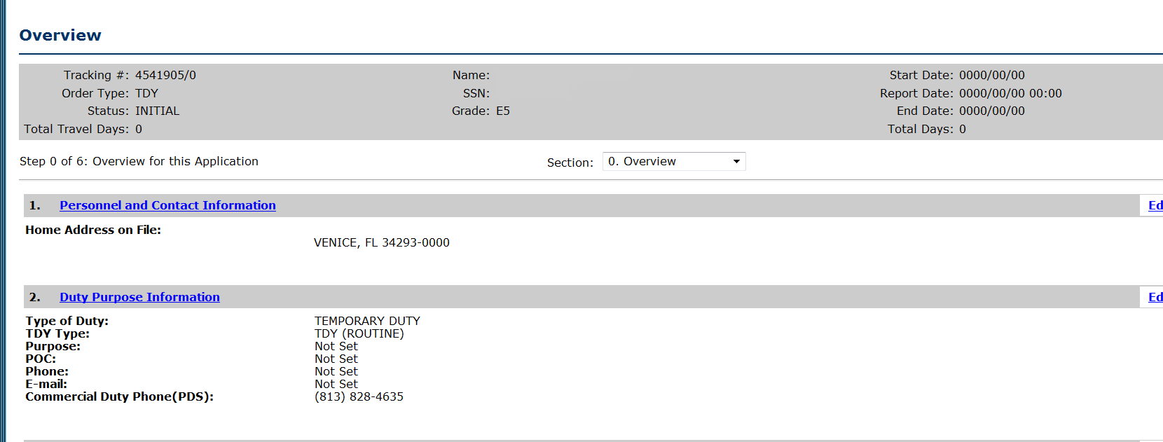
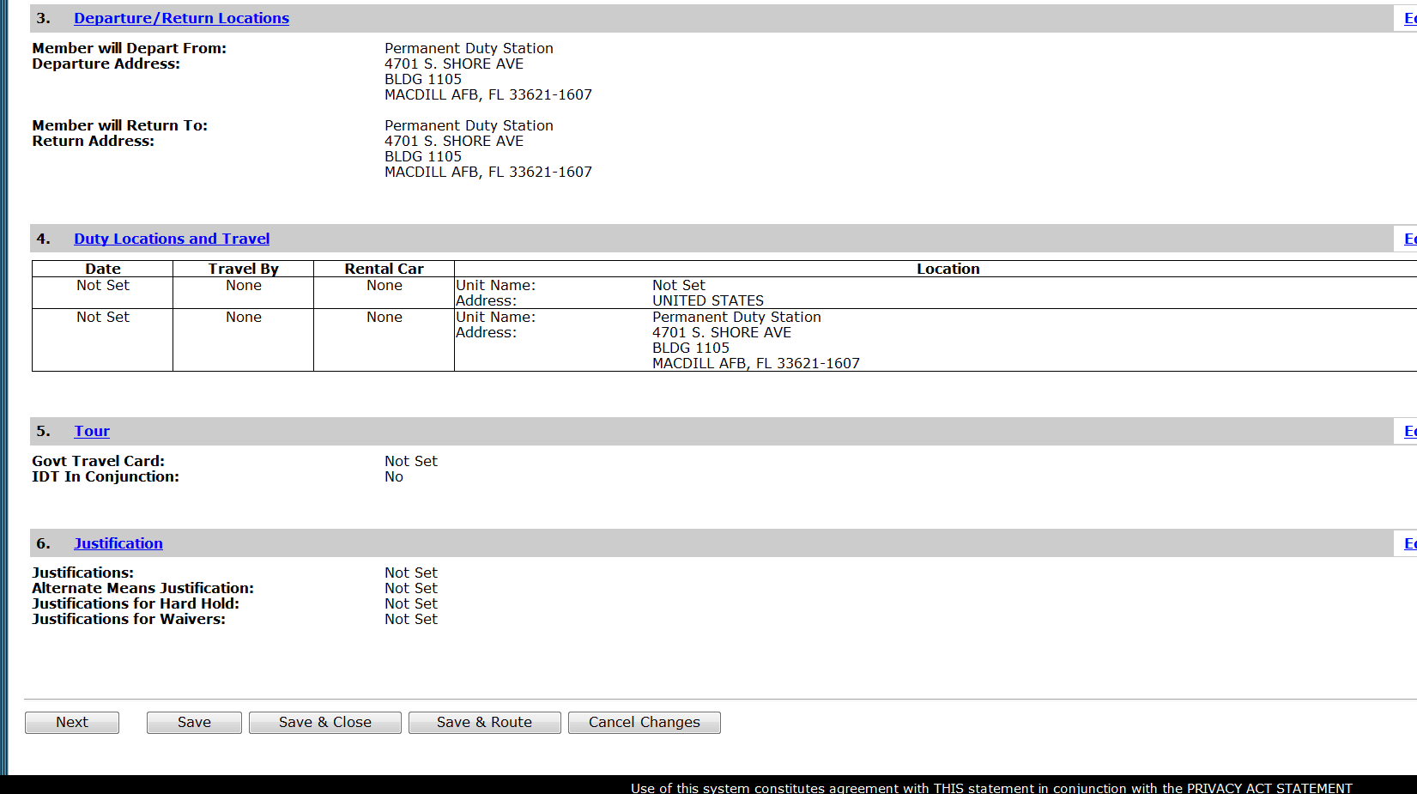
Select Next

Personnel Info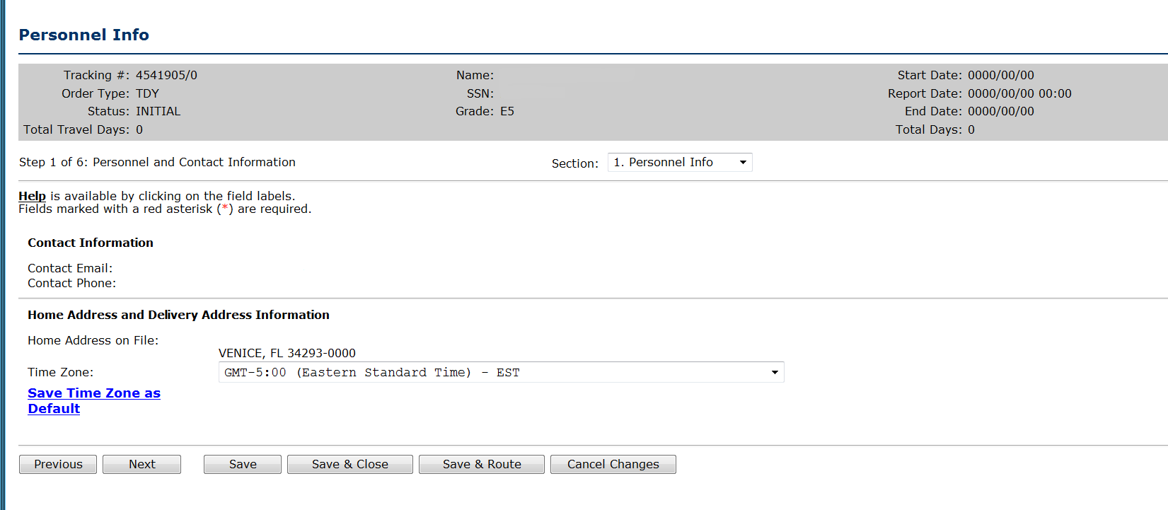
If time zone isn’t save-select and save as Default; Select next.
Duty Purpose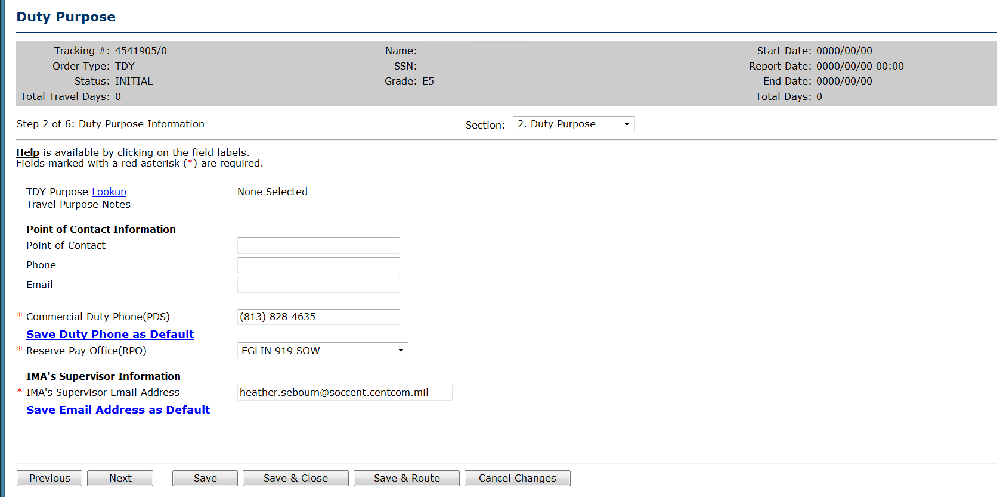
Select TDY Purpose lookup; Select IDT Away from Home Station
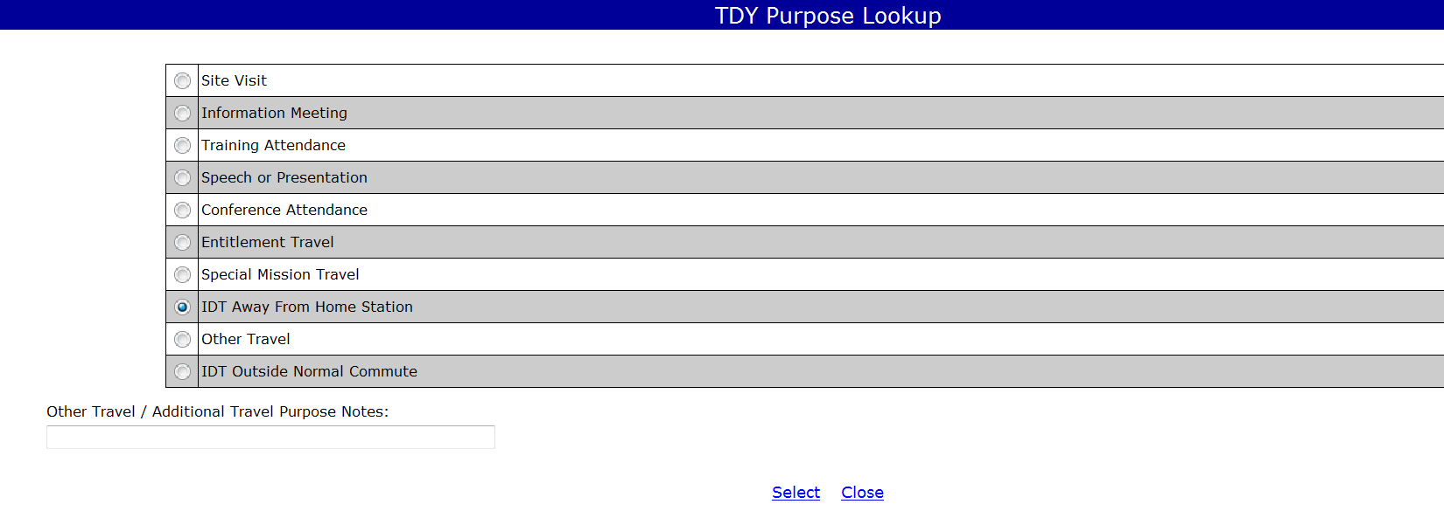
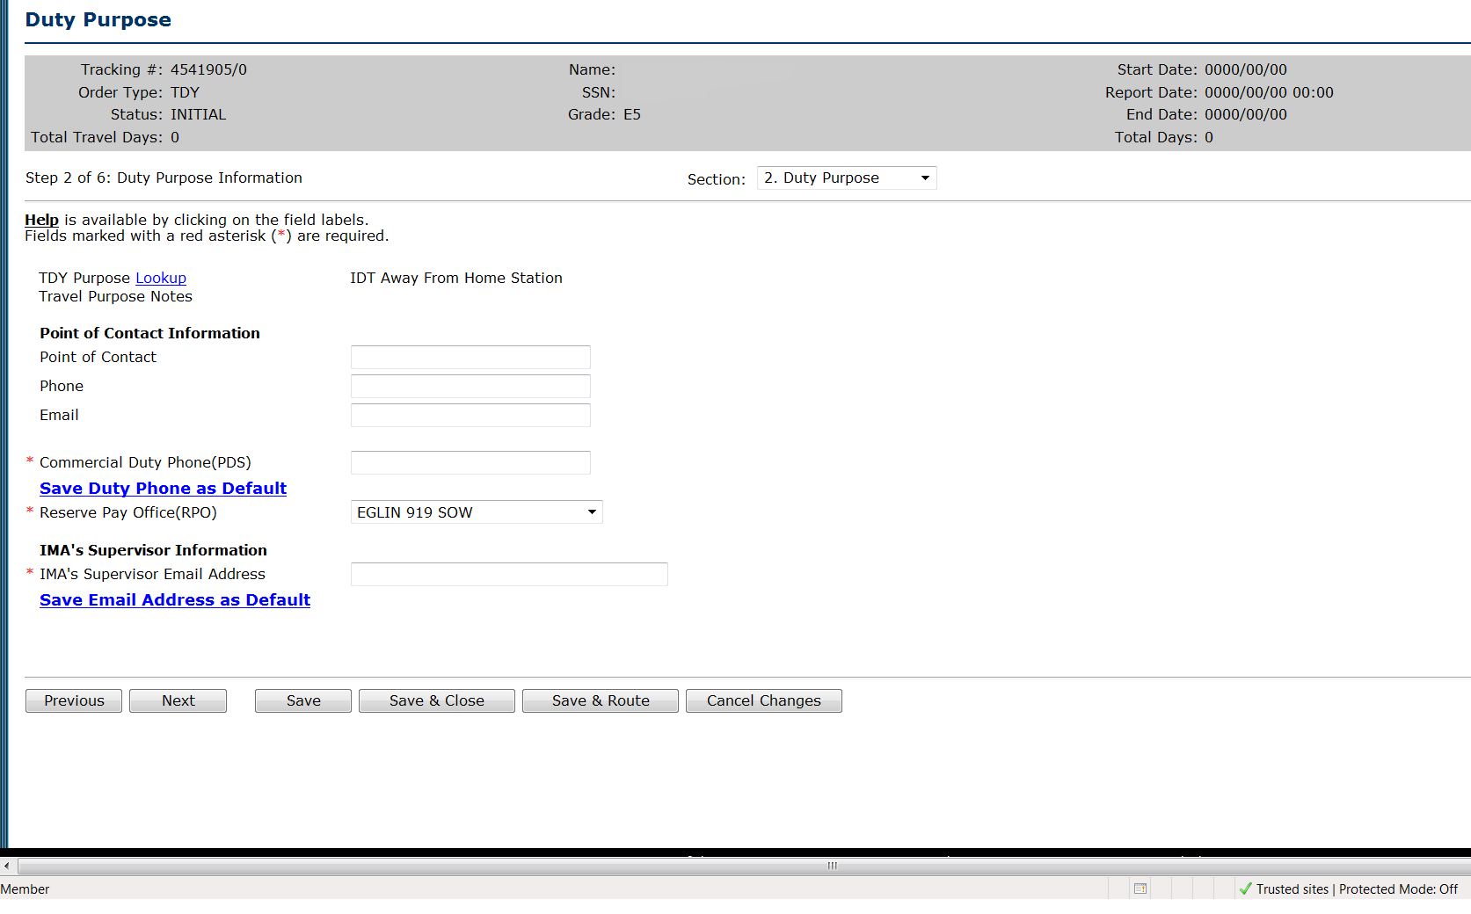
Commercial duty phone is required.
RPO and Supervisor email are required at this time but will be removed in the future.
Select Next.
Departure/Return Locations
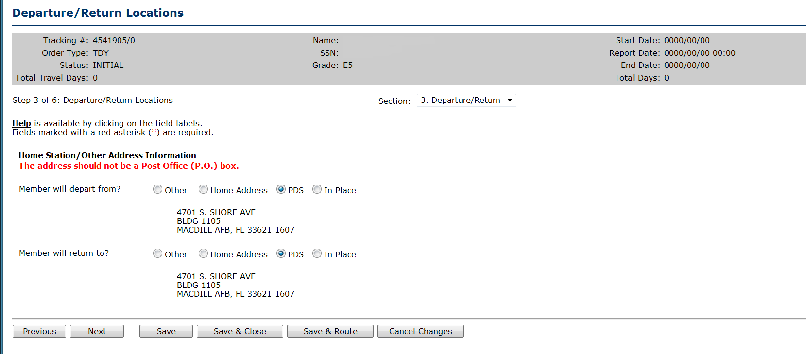
Civilians must depart and return to PDS.
Select Next
Duty Locations- Next screens are same as above.

